Lesson Activity Sheet

School: ……………………………………
Date: ……………………………………….
Class size: …………………………………
Year group: ………………………………..
Application used: Minecraft
Resources: 15 ipad minis, interactive whiteboard
Topic: Numeracy/Minecraft - Symmetry 2
Overview:
Week 2 - More Advanced Symmetry
Students continue working on their symmetrical spaceships and try to include multiple symmetrical objects in their design. Students will also search their 3D creations for the different sectional views that themselves may display one or more lines of symmetry and label these using Minecraft signs.

Week 2
Learning Objective/s:
- To be able to recognise lines of symmetry in a complex object.
- To be able to create complex shapes or 3D objects with more than one line of symmetry.
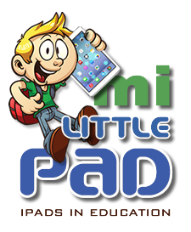
Learning Outcome:
Students should have completed their symmetrical spaceships and have demonstrated AND documented the multiple lines of symmetry present in their designs.
…………………………………………………………………………………………………………………………….
LESSON OUTLINE

Starter input/activity (10 mins)
Produce a quick ‘symmetrical’ 2D portrait of your partner in Minecraft. The face as a whole should be symmetrical but do the children notice any other symmetrical elements e.g. the mouth, eyes and nose should themselves be symmetrical.
Activity (Completing the symmetrical spaceship) 30-40 mins
Building on the starter activity, can the students build multiple symmetrical objects into their spaceship designs and place these new objects (eg laser guns) in symmetrical positions on their designs.

Plenary/Reinforcement
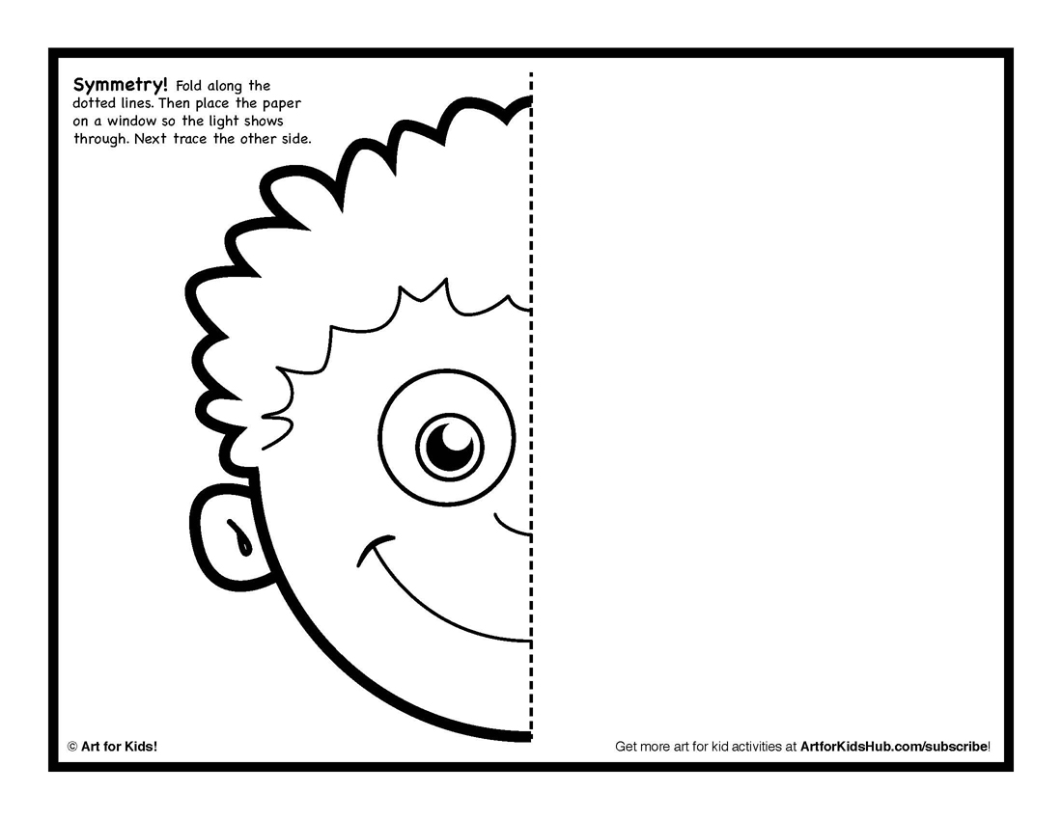
Recap on the learning objectives and get visual feedback from the students as to how the lesson went and their level of understanding. Quantifiable feedback may include a show of fingers (5 for understood really well etc) or the use of mini whiteboards is even better as they can quickly draw the answer to a question and hold it up as a class so you can easily see if the answers are generally correct. Remember, just because one child puts their hand up with the correct answer does not indicate that the class as a whole absorbed the learning objectives!
Differentiation and Extension
More able students will documented/labelled their lines of symmetry using signs
Less able children will have produced more simple shapes and objects and will require more 1to1 intervention.
It might be a good idea to team up bright children with less able one when working in pairs.
Extension - Start to work on the ‘bridge’ or cockpit design or other internal features. Can they spawn a villager inside the spacecraft to fly it?!
National Curriculum:
- Numeracy
- 3D modelling and graphics

