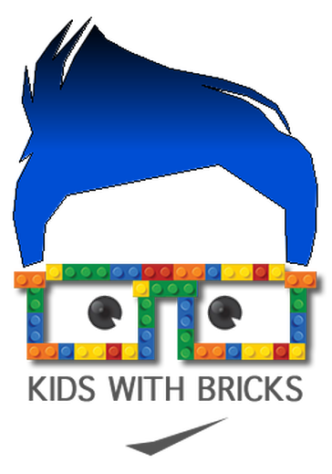
Name of Club | Lego Club
Provider | Kids with Bricks Ltd
Contact Name | Catherine Caines
Telephone | 01633 383211
Email | schools@kidswithbricks.com / cath@milittlepad.com
School Name
First Half of Term Dates
Half Term Dates
Second Half of Term Dates
 | If your club is booked 1 term at a time, please leave Club End date 1 and start date 2 blank.
Club Start Date 1st Half of term
Club End Date 1st Half of Term
Club Start Date 2nd Half of term
Club End Date 2nd Half of Term
Day of Club
Time of Club
Any Events/Trips/Inset Days/Parents Evenings that will affect the club?

*If you have 2 clubs, please write down dates/days/times for both clubs.*
Year Groups
Can we text/email parents to inform them of the club?

